AS5311

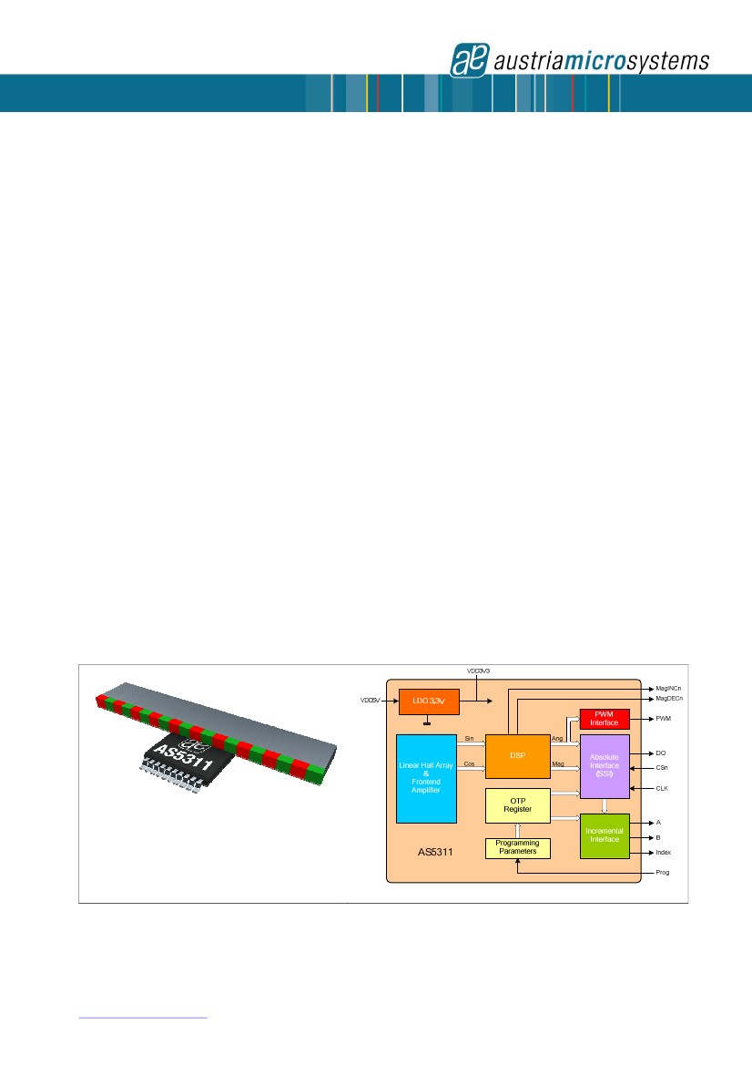

Data Sheet

AS5311

High Resolution Magnetic Linear Encoder

1 General Description

The AS5311 is a contactless high resolution magnetic

linear encoder for accurate linear motion and off-axis

rotary sensing with a resolution down to <0.5µm. It is

a system-on-chip, combining integrated Hall elements,

analog front end and digital signal processing on a

single chip, packaged in a small 20-pin TSSOP

package.

A multi-pole magnetic strip or ring with a pole length

of 1.0mm is required to sense the rotational or linear

motion. The magnetic strip is placed above the IC at a

distance of typ. 0.3mm.

The absolute measurement provides instant indication

of the magnet position within one pole pair with a

resolution of 488nm per step (12-bit over 2.0mm).

This digital data is available as a serial bit stream and

as a PWM signal.

Furthermore, an incremental output is available with a

resolution of 1.95 µm per step. An index pulse is

generated once for every pole pair (once per

2.0mm).The travelling speed in incremental mode is

up to 650mm/second.

An internal voltage regulator allows the AS5311 to

operate at either 3.3 V or 5 V supplies.

Depending on the application the AS5311 accepts

multi-pole strip magnets as well as multi-pole ring

magnets, both radial and axial magnetized (see

Figure 1 and Figure 3).

Figure 1. AS5311 with Multi-pole Magnetic Strip

for Linear Motion Sensing

Preliminary Data Sheet

The AS5311 is available in a Pb-free TSSOP-20

package and qualified for an ambient temperature

range from -40°C to +125°C.

2 Key Features

Two 12-bit digital absolute outputs :

- Serial interface and

- Pulse width modulated (PWM) output

Incremental output with Index

“red-yellow-green” indicators monitor magnet

placement over the chip

3 Applications

Micro-Actuator feedback

Servo drive feedback

Robotics

Replacement of optical encoders

Figure 2. Block Diagram of AS5311

www.austriamicrosystems.com

Revision 1.05

1 - 23

AS5311

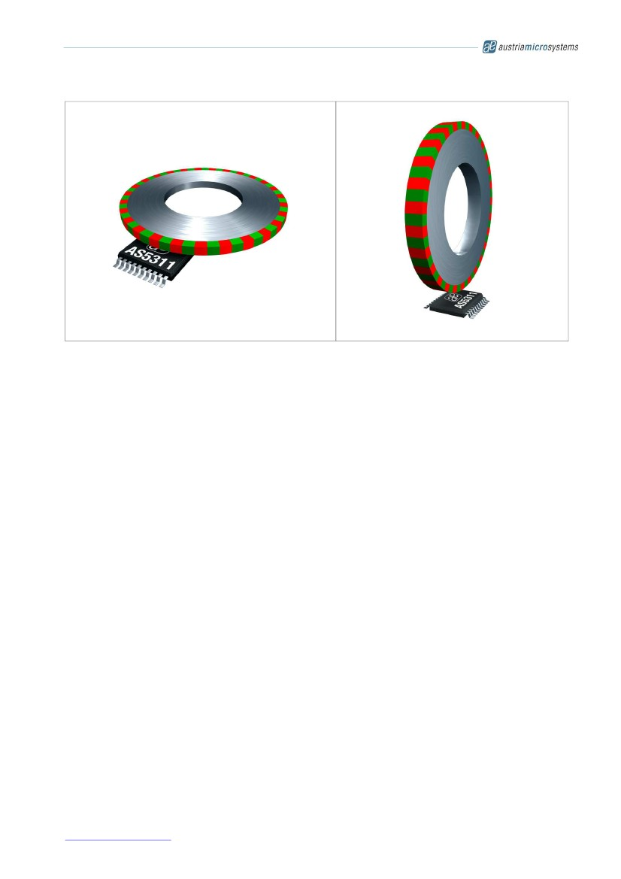

Data Sheet

Figure 3. AS5311 with Multi-pole Ring Magnets for Off-axis Rotary Motion Sensing

www.austriamicrosystems.com

Revision 1.05

2 - 23

AS5311



Data Sheet

4 Table of Contents

1

2

3

4

5

General Description ...................................................................................................................... 1

Key Features ................................................................................................................................ 1

Applications.................................................................................................................................. 1

Table of Contents ......................................................................................................................... 3

Pinout .......................................................................................................................................... 5

5.1

5.2

6

Pin Assignments ..................................................................................................................... 5

Pin Description ....................................................................................................................... 5

Electrical Characteristics............................................................................................................... 6

6.1

6.2

6.3

Absolute Maximum Ratings ..................................................................................................... 6

Operating Conditions .............................................................................................................. 7

DC Characteristics for Digital Inputs and Outputs ..................................................................... 7

CMOS Schmitt-Trigger Inputs: CLK, CSn (CSn = internal Pull-up) ....................................... 7

CMOS Output Open Drain: MagINCn, MagDECn ................................................................ 7

CMOS Output: PW M ......................................................................................................... 7

Tristate CMOS Output: DO ................................................................................................ 8

6.3.1

6.3.2

6.3.3

6.3.4

6.4

6.5

6.6

Magnetic Input Specification.................................................................................................... 8

Electrical System Specifications .............................................................................................. 8

Timing Characteristics ............................................................................................................ 9

Synchronous Serial Interface (SSI) .................................................................................... 9

Pulse Width Modulation Output........................................................................................ 10

6.6.1

6.6.2

7

Detailed Description.................................................................................................................... 10

7.1

Incremental Outputs.............................................................................................................. 11

Incremental Power-up Lock Option .................................................................................. 11

7.1.1

7.2

7.3

Incremental Output Hysteresis............................................................................................... 12

Synchronous Serial Interface (SSI) ........................................................................................ 12

Data Contents ................................................................................................................ 13

7.3.1

7.4

Absolute Output Jitter and Hysteresis .................................................................................... 14

Adding a Digital Hysteresis ............................................................................................. 14

Implementing Digital Filtering .......................................................................................... 14

7.4.1

7.4.2

7.5

8

9

10

Z-axis Range Indication (“Red/Yellow/Green” Indicator) .......................................................... 14

Pulse Width Modulation (PWM) Output ........................................................................................ 15

3.3V / 5V Operation .................................................................................................................... 15

Magnet Specifications .............................................................................................................. 16

Magnetization .................................................................................................................... 16

Position of the Index Pulse ................................................................................................. 17

Mounting the Magnet ......................................................................................................... 17

Vertical Distance ......................................................................................................... 17

Alignment of Multi-pole Magnet and IC.......................................................................... 17

Lateral stroke of Multi-pole Strip Magnets ..................................................................... 17

10.1

10.2

10.3

10.3.1

10.3.2

10.3.3

11

Measurement Data Example ..................................................................................................... 19

Revision 1.05

3 - 23

www.austriamicrosystems.com

AS5311



Data Sheet

12

13

14

15

16

17

18

AS5311 Off-axis Rotary Applications ........................................................................................ 20

Package Drawings and Marking ................................................................................................ 21

Ordering Information ................................................................................................................ 22

Recommended PCB Footprint................................................................................................... 22

Revision History ...................................................................................................................... 23

Copyrights ............................................................................................................................... 23

Disclaimer ............................................................................................................................... 23

www.austriamicrosystems.com

Revision 1.05

4 - 23

AS5311

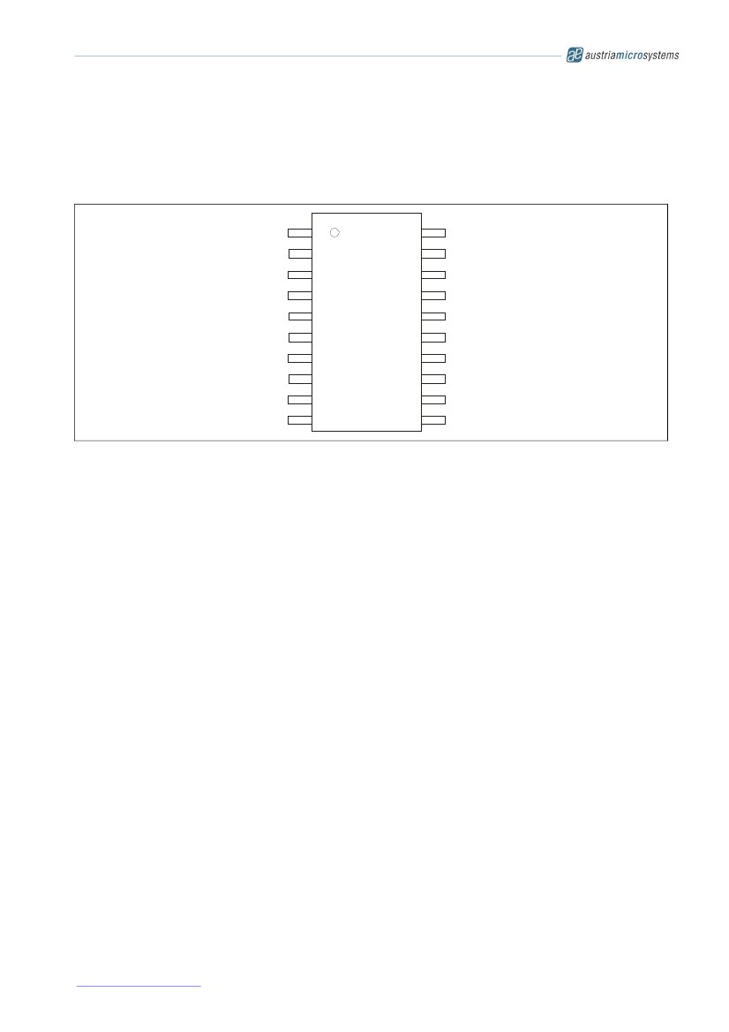

Data Sheet

5 Pinout

5.1 Pin Assignments

Figure 4. AS5311 Pin Configuration, TSSOP-20

NC

MagIncn

MagDecn

A

B

NC

Index

VSS

Prog

NC

1

2

3

4

5

6

7

8

9

10

20

19

18

NC

VDD5V

VDD3V3

NC

NC

PWM

CSn

CLK

DO

NC

AS5311

are

for

17

16

15

14

13

12

11

5.2 Pin Description

Pin 4(A), 5(B) and 7(Index) are the incremental outputs. The incremental output has a resolution of 10-bit per

pole pair, resulting in a step length of 1.95µm.

Note that Pin 14 (CSn) must be low to enable the incremental outputs.

Pins 12, 13 and 14 are used for serial data transfer. Chip Select (CSn; active low) initiates serial data transfer.

CLK is the clock input and DO is the data output. A logic high at CSn puts the data output pin (DO) to tri-state

and terminates serial data transfer. CSn must be low to enable the incremental outputs. See 7.1.1 for further

options.

Pin 8 is the supply ground pin. Pins 18 and 19 are the positive supply pins.

For 5V operation, connect the 5V supply to pin 19 and add a 2µ2…10µF buffer capacitor at pin 18.

For 3.3V operation, connect both pins 18 and 19 to the 3.3V supply.

Pin 9 is used for factory programming only. It should be connected to VSS.

Pins 2 and 3 are the magnetic field change indicators, MagINCn and MagDECn (magnetic field strength increase

or decrease through variation of the distance between the magnet and the device). These outputs can be used

to detect the valid magnetic field range.

External pull-up resistors are required at these pins. See 6.3.2 for maximum output currents on these pins. Since

they are open-drain outputs they can also be combined (wired-and).

Pin 15 (PWM) allows a single wire output of the 12-bit absolute position value within one pole pair (2.0mm). The

value is encoded into a pulse width modulated signal with 1µs pulse width per step (1µs to 4097µs over one pole

pair).

Pins

1,

6,

10,

11,

16,

17

and

20

internal

use

and

must

not

be

connected.

www.austriamicrosystems.com

Revision 1.05

5 - 23

AS5311

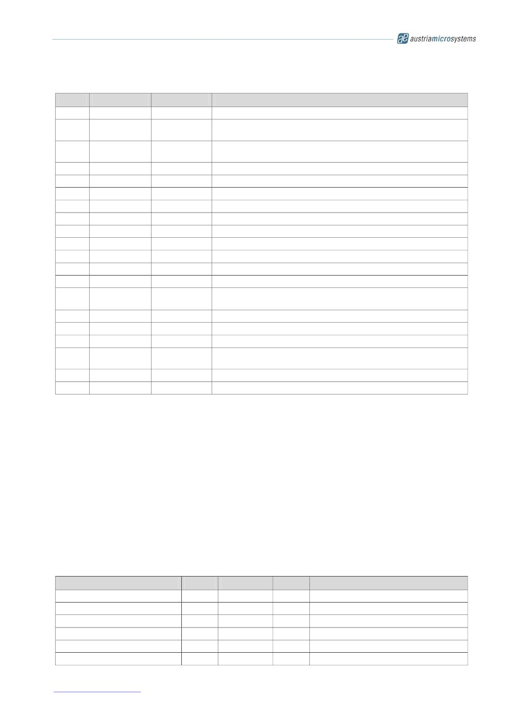

Data Sheet

Table 1. Pin Description

Pin

1

2

3

4

5

6

7

8

9

10

11

12

13

14

15

16

17

18

19

20

DO_OD

DO

DI_PD

DI_PU

Symbol

NC

MagINCn

MagDECn

A

B

NC

Index

VSS

Prog

NC

NC

DO

CLK

CSn

PWM

NC

NC

VDD3V3

VDD5V

NC

digital

digital

digital

digital

Type

-

DO_OD

DO_OD

DO

DO

-

DO

S

DI_PD

-

-

DO_T

DI, ST

DI_PU, ST

DO

-

-

S

S

-

Must be left unconnected

Magnet Field Magnitude INCrease; active low, indicates a distance

reduction between the magnet and the device surface.

Magnet Field Magnitude DECrease; active low, indicates a distance

increase between the device and the magnet.

Incremental output A

Incremental output B

Must be left unconnected

Incremental output Index.

Negative Supply Voltage (GND)

OTP Programming Input for factory programming. Connect to VSS

Must be left unconnected

Must be left unconnected

Data Output of Synchronous Serial Interface

Clock Input of Synchronous Serial Interface; Schmitt-Trigger input

Chip Select, active low; Schmitt-Trigger input, internal pull-up resistor

(~50kΩ). Must be low to enable incremental outputs

Pulse Width Modulation of approx. 244Hz; 1µs/step

Must be left unconnected

Must be left unconnected

3V-Regulator output; internally regulated from VDD5V. Connect to

VDD5V for 3V supply voltage. Do not load externally.

Positive Supply Voltage, 3.0 to 5.5 V

Must be left unconnected

S

DI

DO_T

ST

supply pin

digital input

digital output /tri-state

Schmitt-Trigger input

Description

output open drain

output

input pull-down

input pull-up

6 Electrical Characteristics

6.1 Absolute Maximum Ratings

Stresses beyond those listed under “Absolute Maximum Ratings“ may cause permanent damage to the device.

These are stress ratings only. Functional operation of the device at these or any other conditions beyond those

indicated under “Operating Conditions” is not implied. Exposure to absolute maximum rating conditions for

extended periods may affect device reliability.

Table 2. Absolute Maximum Ratings

Parameter

DC supply voltage at pin VDD5V

DC supply voltage at pin VDD3V3

Input pin voltage

Input current (latchup immunity)

Electrostatic discharge

Storage temperature

-55

-0.3

-100

Min

-0.3

Max

7

5

VDD5V +0.3

100

±2

125

Unit

V

V

V

mA

kV

°C

Except VDD3V3

Norm: JEDEC 78

Norm: MIL 883 E method 3015

Min – 67° ; Max +257 °FF

Comments

www.austriamicrosystems.com

Revision 1.05

6 - 23

AS5311

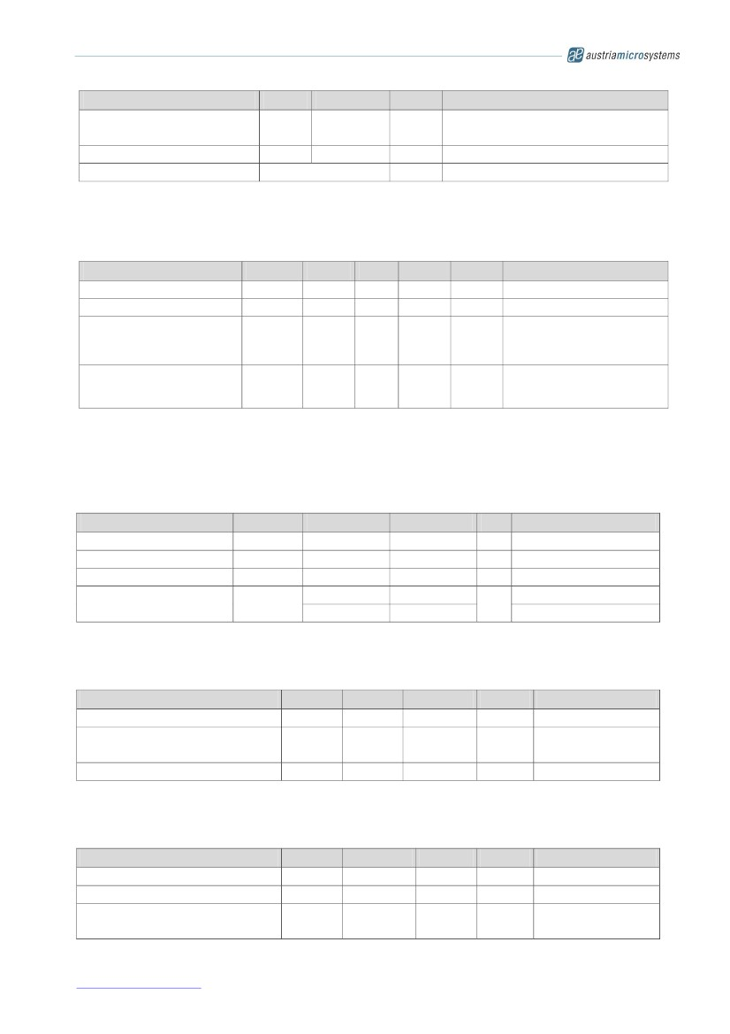

Data Sheet

Parameter

Body temperature

Humidity non-condensing

Moisture Sensitive Level

Min

Max

260

Unit

°C

%

Comments

Norm: IPC/JEDEC J-Std-020C

Lead finish 100% Sn “matte tin”

Represents a maximum floor life time of 168h

5

3

85

6.2 Operating Conditions

Table 3. Operating Conditions

Parameter

Ambient temperature

Supply current

Supply voltage at pin VDD5V

Voltage regulator output

voltage at pin VDD3V3

Supply voltage at pin VDD5V

Supply voltage at pin VDD3V3

Symbol

Tamb

Isupp

VDD5V

VDD3V3

VDD5V

VDD3V3

4.5

3.0

3.0

3.0

Min

-40

16

5.0

3.3

3.3

3.3

Typ

Max

125

21

5.5

3.6

3.6

3.6

Unit

°C

mA

V

V

V

V

5V Operation

3.3V Operation

(pin VDD5V and VDD3V3

connected)

Note

-40°F…+257°F

6.3 DC Characteristics for Digital Inputs and Outputs

6.3.1

CMOS Schmitt-Trigger Inputs: CLK, CSn (CSn = internal Pull-up)

Operating conditions: Tamb = -40 to +125°C, VDD5V = 3.0-3.6V (3V operation) VD D5V = 4.5-5.5V (5V operation) unless

otherwise noted.

Parameter

High level input voltage

Low level input voltage

Schmitt Trigger hysteresis

Input leakage current

Pull-up low level input current

Symbol

VIH

VIL

VIon - VIoff

ILEAK

IiL

Min

0.41 * VDD5V

Max

0.13 * VDD5V

Unit

V

V

V

CLK only

Note

Normal operation

1

-1

-30

1

-100

µA

CSn only, VDD5V: 5.0V

6.3.2

CMOS Output Open Drain: MagINCn, MagDECn

Operating conditions: Tamb = -40 to +125°C, VDD5V = 3.0-3.6V (3V operation) VD D5V = 4.5-5.5V (5V operation) unless

otherwise noted.

Parameter

Low level output voltage

Output current

Open drain leakage current

Symbol

VOL

IO

IOZ

Min

Max

VSS+0.4

4

2

1

Unit

V

mA

µA

Note

VDD5V: 4.5V

VDD5V: 3V

6.3.3

CMOS Output: PWM

Operating conditions: Tamb = -40 to +125°C, VDD5V = 3.0-3.6V (3V operation) VD D5V = 4.5-5.5V (5V operation) unless

otherwise noted.

Parameter

High level output voltage

Low level output voltage

Output current

Symbol

VOH

VOL

IO

Min

VDD5V-0.5

Max

VSS+0.4

4

2

Unit

V

V

mA

mA

Note

VDD5V: 4.5V

VDD5V: 3V

www.austriamicrosystems.com

Revision 1.05

7 - 23

AS5311

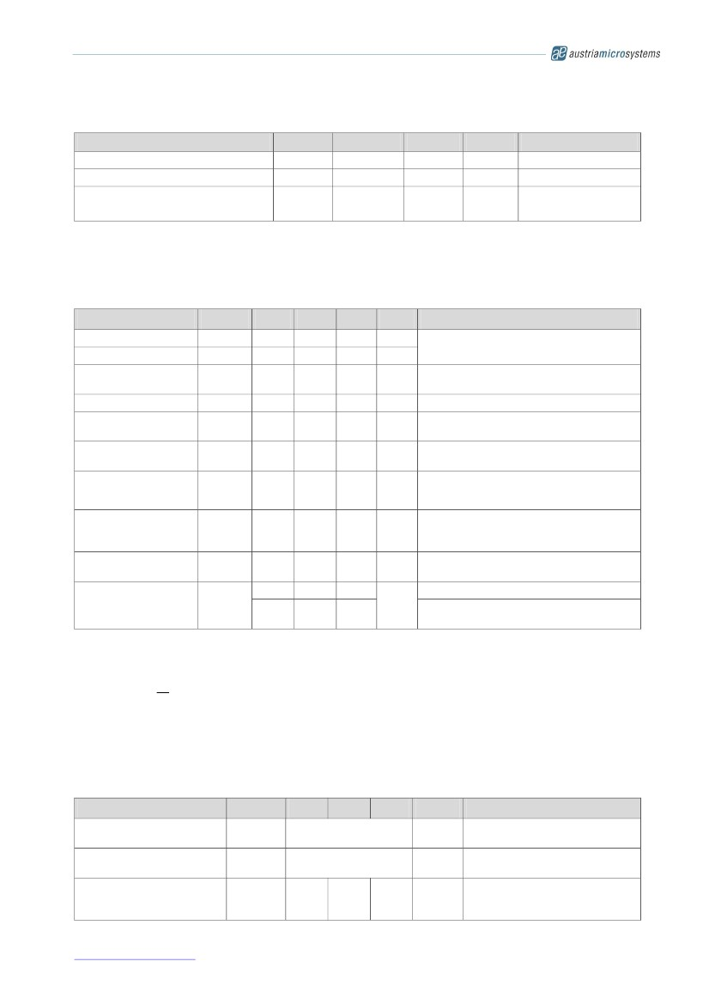

Data Sheet

6.3.4

Tristate CMOS Output: DO

Operating conditions: Tamb = -40 to +125°C, VDD5V = 3.0-3.6V (3V operation) VD D5V = 4.5-5.5V (5V operation) unless

otherwise noted.

Parameter

High level output voltage

Low level output voltage

Output current

Symbol

VOH

VOL

IO

Min

VDD5V –0.5

Max

VSS+0.4

4

2

Unit

V

V

mA

mA

Note

VDD5V: 4.5V

VDD5V: 3V

6.4 Magnetic Input Specification

Operating conditions: Tamb = -40 to +125°C, VDD5V = 3.0-3.6V (3V operation) VD D5V = 4.5 - 5.5V (5V operation) unless

otherwise noted.

Two-pole cylindrical diametrically magnetised source:

ParameterSymbolMinTypMax

Pole length

Pole pair length

Magnetic input field

amplitude

Magnetic offset

Magnetic field

temperature drift

Magnetic input field

variation

Linear travelling speed

Vabs

Lp

tmag

Bpk

Boff

Btc

10

1

2

40

±5

0.2

±2

650

Unit

mm

mm

mT

mT

%/K

%

mm/

sec

mm

mm

Note

Recommended magnet: plastic or rubber

bonded ferrite or NdFeB

Required vertical component of the magnetic

field strength on the die’s surface

Constant magnetic stray field

Recommended magnet: plastic or rubber

bonded ferrite or NdFeB

Including offset gradient

Incremental output: 1024 steps / polepair

1)

including interpolation

Max. shift between defined Hall sensor

center and magnet centerline (see Figure

17); depends on magnet geometries

Package to magnet surface;

depends on magnet strength

Plastic or rubber bonded Ferrite

Plastic or rubber bonded Neodymium

(NdFeB)

Displacement

Vertical gap

Recommended magnet

material and

temperature drift

1)

Disp

ZDist

0.5

0.3

-0.19

-0.12

%/K

Note : There is no upper speed limit for the absolute outputs. With increasing speed, the distance between two

samples increases. The travelling distance between two subsequent samples can be calculated as:

sampling _ dist =

v

fs

where: sampling_distance = travelling distance between samples in mm

v = travelling speed in mm/sec

fs = sampling rate in Hz(see 6.5 below)

6.5 Electrical System Specifications

Operating conditions: Tamb = -40 to +125°C, VDD5V = 3.0~3.6V (3V operation) VD D5V = 4.5~5.5V (5V operation) unless

otherwise noted.

Parameter

Resolution, absolute outputs

Resolution, incremental

outputs

Integral non-linearity

(optimum)

Symbol

RESabs

RESinc

INLopt

Min

Typ

12

10

Max

Unit

bit /

polepair

bit /

polepair

Note

0.488 um/step (12bit / 2mm pole

pair)

1.95 um/step (10bit / 2mm pole

pair)

Maximum error with respect to the

best line fit. Ideal magnet

Tamb =25 °C.

± 5.6

µm

www.austriamicrosystems.com

Revision 1.05

8 - 23

AS5311

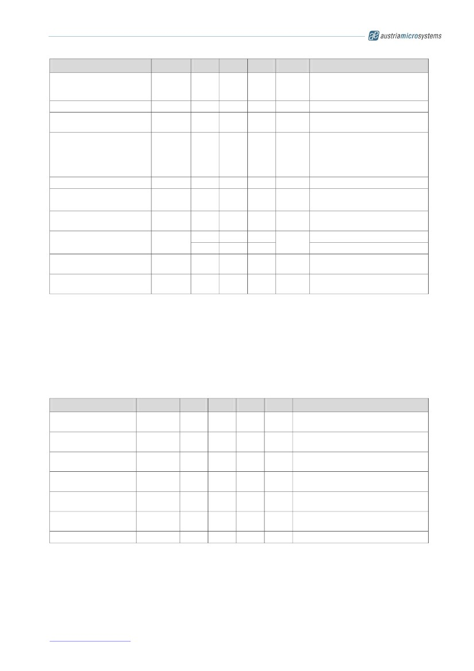

Data Sheet

Parameter

Integral non-linearity (over

temperature)

Differential non-linearity

Transition noise

Power-on reset thresholds

On voltage; 300mV typ.

hysteresis

Off voltage; 300mV typ.

hysteresis

Power-up time

System propagation delay

absolute output :

System propagation delay

incremental output

Internal sampling rate for

absolute output

Hysteresis, incremental

outputs

Read-out frequency

Symbol

INLtemp

DNL

TN

Von

Voff

tPwrUp

tdelay

tdelay

fS

Hyst

CLK

Min

Typ

Max

± 10

±0.97

0.6

Unit

µm

µm

µm

RMS

Note

Maximum error with respect to the

best line fit. Ideal magnet

Tamb = -30 to +70 °C.

10bit, no missing codes

1 sigma

DC supply voltage 3.3V (VDD3V3)

1.37

1.08

2.2

1.9

2.9

V

2.6

20

96

384

ms

µs

µs

kHz

LSB

1

MHz

DC supply voltage 3.3V (VDD3V3)

Until status bit OCF = 1

Delay of ADC, DSP and absolute

interface

Including interpolation delay at

high speeds

Tamb = 25°C

Tamb = -40 to +125°C,

No Hysteresis at absolute serial

outputs

Max. clock frequency to read out

serial data

9.90

9.38

10.42

10.42

2

10.94

11.46

Integral Non-Linearity (INL) is the maximum deviation between actual position and indicated position.

Differential Non-Linearity (DNL) is the maximum deviation of the step length from one position to the next.

Transition Noise (TN) is the repeatability of an indicated position.

6.6 Timing Characteristics

6.6.1

Synchronous Serial Interface (SSI)

Operating conditions: Tamb = -40 to +125°C, VDD5V = 3.0~3.6V (3V operation) VD D5V = 4.5~5.5V (5V operation) unless

otherwise noted.

Parameter

Data output activated

(logic high)

First data shifted to

output register

Start of data output

Data output valid

Data output tristate

Pulse width of CSn

Read-out frequency

Symbol

t DO active

tCLK FE

T CLK / 2

t DO valid

t DO

tristate

t CSn

fCLK

Min

Typ

Max

100

Unit

ns

ns

ns

Note

Time between falling edge of CSn and

data output activated

Time between falling edge of CSn and

first falling edge of CLK

Rising edge of CLK shifts out one bit at

a time

Time between rising edge of CLK and

data output valid

After the last bit DO changes back to

“tristate”

CSn = high; To initiate read-out of next

angular position

Clock frequency to read out serial data

500

500

413

100

500

>0

1

ns

ns

ns

MHz

www.austriamicrosystems.com

Revision 1.05

9 - 23

AS5311

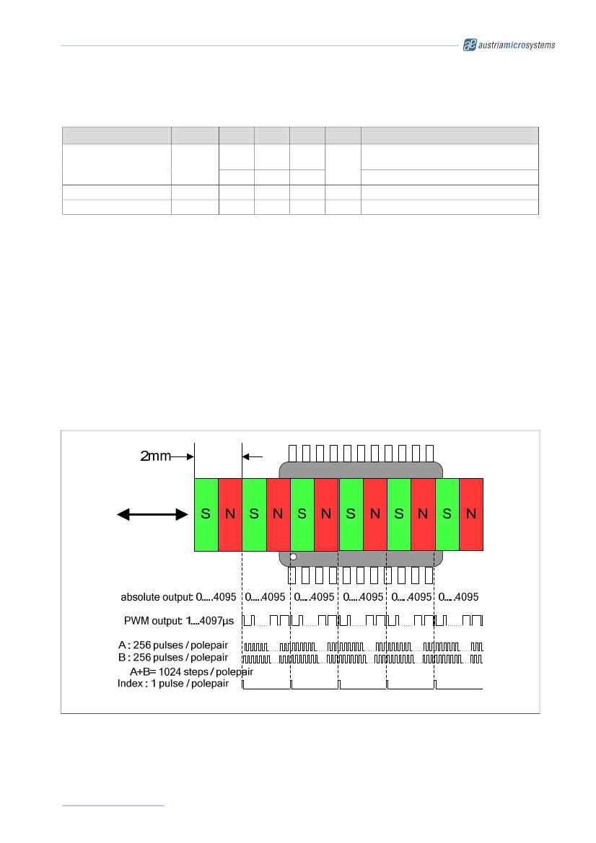

Data Sheet

6.6.2

Pulse Width Modulation Output

Operating conditions: Tamb = -40 to +125°C, VDD5V = 3.0~3.6V (3V operation) VD D5V = 4.5~5.5V (5V operation) unless

otherwise noted.

Parameter

PWM frequency

Minimum pulse width

Maximum pulse width

Symbol

f PWM

PW MIN

PW MAX

Min

232

220

0.9

3892

Typ

244

244

1

4097

Max

256

268

1.1

4301

Unit

Hz

µs

µs

Note

Signal period = 4098µs ±5% at Tamb =

25°C

= 4098µs ±10% at Tamb = -40 to +125°C

Position 0d =0µm

Position 4095d = 1999.5µm

7 Detailed Description

The different types of outputs relative to the magnet position are outlined in Figure 5 below.

The absolute serial output counts from 0….4095 within one pole pair and repeats with each subsequent pole

pair.

Likewise, the PWM output starts with a pulse width of 1µs, increases the pulse width with every step of 0.488µm

and reaches a maximum pulse width of 4097µs at the end of each pole pair.

An index pulse is generated once for every pole pair.

256 incremental pulses are generated at each output A and B for every pole pair. The outputs A and B are

phase shifted by 90 electrical degrees, which results in 1024 edges per pole pair. As the incremental outputs are

also repeated with every pole pair, a constant train of pulses is generated as the magnet moves over the chip.

Figure 5. AS5311 Outputs Relative to Magnet Position

www.austriamicrosystems.com

Revision 1.05

10 - 23

AS5311

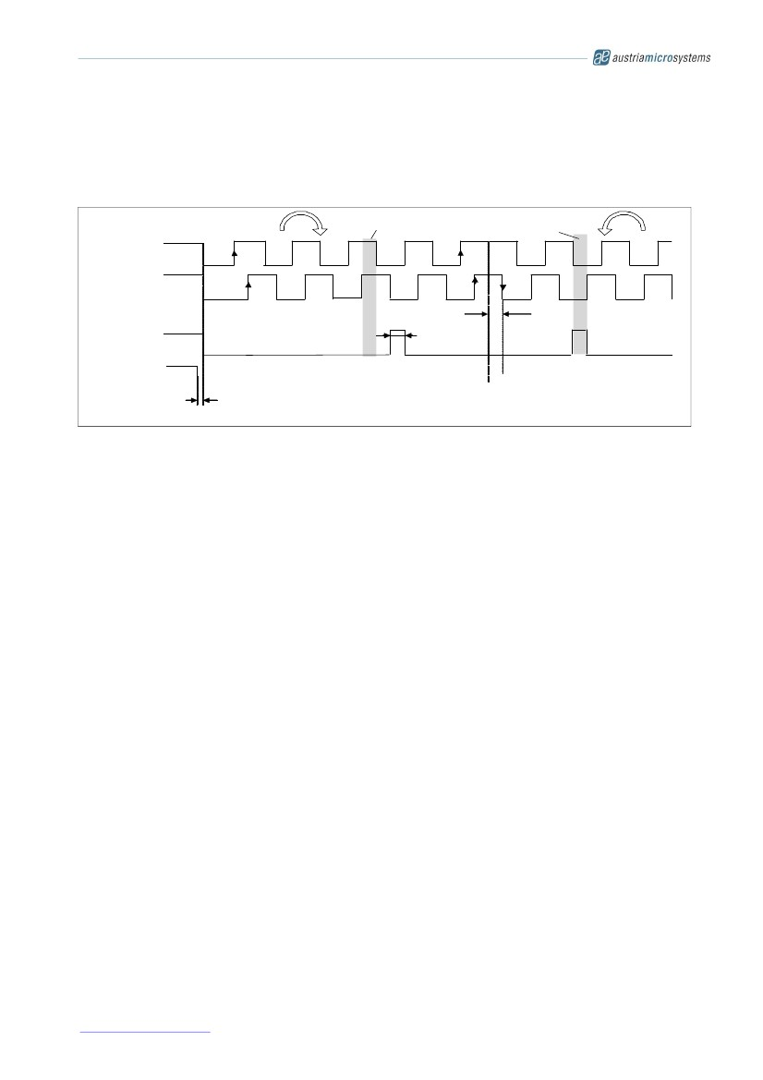

Data Sheet

7.1 Incremental Outputs

Figure 6 shows the two-channel quadrature output of the AS5311. Output A leads output B when the magnet is

moving from right to left and output B leads output A when the magnet is moving from left to right

(see Figure 14).

Figure 6. Incremental Outputs

Increm en tal outputs

A

B

M echanical

Z ero P osition

M ovem ent Direction

Change

M echanical

Zero Position

Index= 0

1 LSB

In d e x

H y st =

2 LSB

CS n

t

In cre m e n tal o u tp u ts va lid

Movem ent righ t to left

Mo vem en t le ft to righ t

7.1.1

Incremental Power-up Lock Option

After power-up, the incremental outputs can optionally be locked or unlocked, depending on the status of the

CSn pin:

CSn = low at power-up:

CSn has an internal pull-up resistor and must be externally pulled low (Rext ≤ 5kΩ). If Csn is low at

power-up, the incremental outputs A, B and Index will be high until the internal offset compensation is

finished.

This unique state may be used as an indicator for the external controller to shorten the waiting time at

power-up. Instead of waiting for the specified maximum power up-time (see 6.5), the controller can start

requesting data from the AS5311 as soon as the state (A=B=Index = high) is cleared.

CSn = high or open at power-up:

In this mode, the incremental outputs (A, B, Index) will remain at logic high state, until CSn goes low or

a low pulse is applied at CSn. This mode allows intentional disabling of the incremental outputs until for

example the system microcontroller is ready to receive data.

www.austriamicrosystems.com

Revision 1.05

11 - 23

AS5311

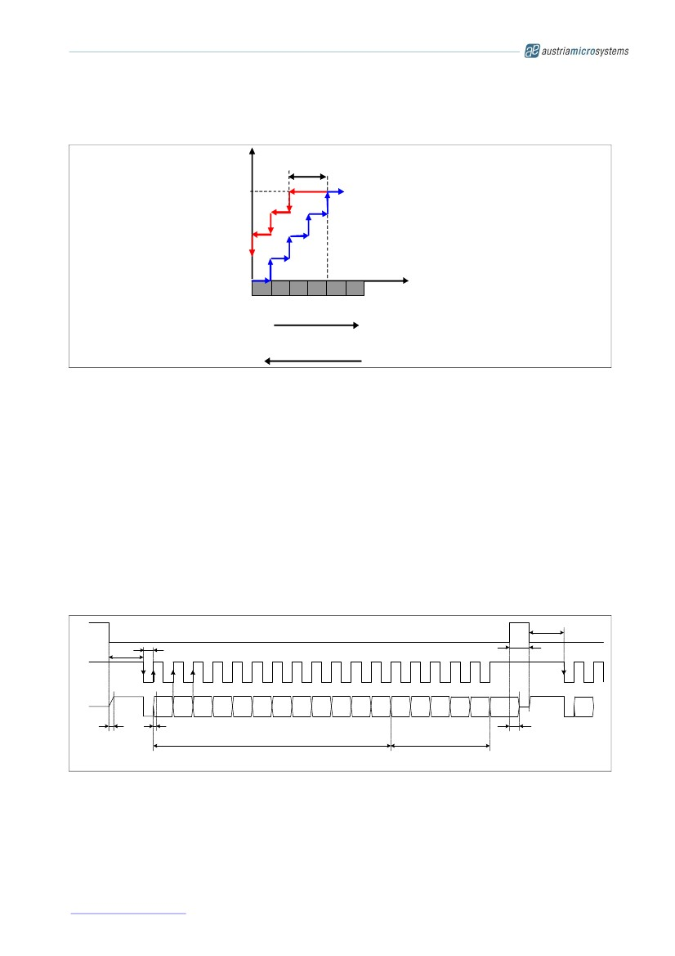

Data Sheet

7.2 Incremental Output Hysteresis

Figure 7. Hysteresis Illustration

Incremental

Output

Indication

X +4

X +3

X +2

X +1

X

X

X +1 X +2 X +3 X +4 X +5

Magnet Position

Hysteresis:

2 steps

Movement left -> right

Movement right -> left

To avoid flickering incremental outputs at a stationary magnet position, a hysteresis is introduced.

In case of a movement direction change, the incremental outputs have a hysteresis of 2 LSB. For constant

movement directions, every magnet position change is indicated at the incremental outputs (see Figure 6). If for

example the magnet moves from position „x+3“ to „x+4“, the incremental output would also indicate this position

accordingly.

A change of the magnet’s movement direction back to position „x+3“ means, that the incremental output still

remains unchanged for the duration of 2 LSB, until position „x+2“ is reached. Following this movement, the

incremental outputs will again be updated with every change of the magnet position.

7.3 Synchronous Serial Interface (SSI)

The Serial interface allows data transmission of the 12-bit absolute linear position information (within one pole

pair = 2.0mm). Data bits D11:D0 represent the position information with a resolution of 488nm (2000µm / 4096)

per step.

CLK must be high before and at the falling edge of CSn.

Figure 8. Synchronous Serial Interface with Absolute Angular Position Data

CSn

tCLK FE

TCLK/2

1

8

18

tCSn

1

tCLK FE

CLK

DO

D11

D10

D9

D8

D7

D6

D5

D4

D3

D2

D1

D0

OCF

COF

LIN

Mag

INC

Mag

DEC

Even

PAR

D11

tDO active

tDO valid

Angular Position Data

Status Bits

tDO Tristate

If CLK is low before and at the falling edge of CSn, the first 12 bits represent the magnitude information, which is

proportional to the magnetic field strength. This information can be used to detect the presence and proper

distance of the magnetic strip by comparing it to a known good value (depends on the magnet material and

distance).

The automatic gain control (AGC) maintains a constant MAGnitude value of 3F hex (=”green” range). If the MAG

value is <>3F hex, the AGC is out of the regulating range (“yellow” or “red” range). See Table 5 for more details.

www.austriamicrosystems.com

Revision 1.05

12 - 23

AS5311

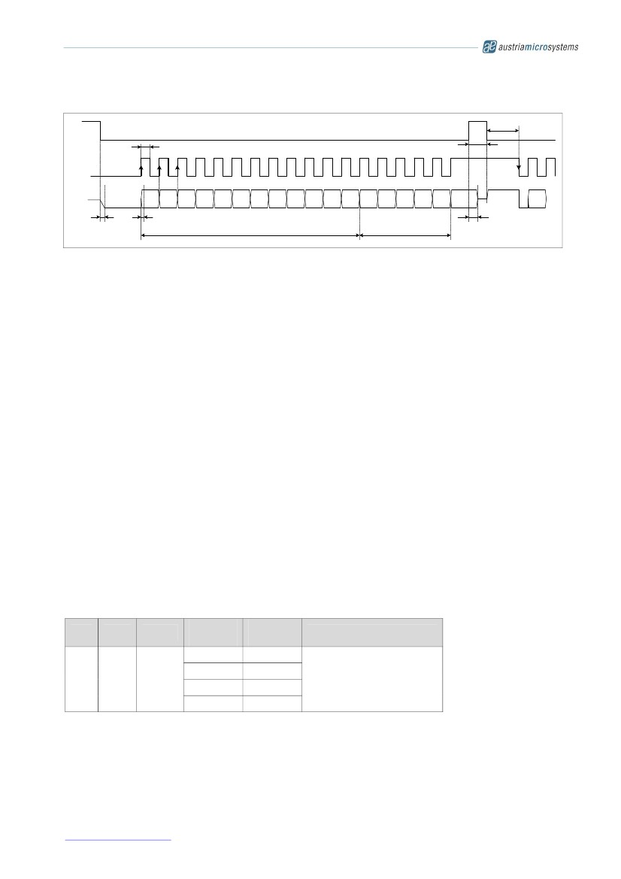

Data Sheet

A value of zero or close to zero indicates a missing magnet.

Figure 9. Synchronous Serial Interface with Magnetic Field Strength Data

CSn

TCLK/2

tCSn

8

18

1

tCLK FE

CLK

1

DO

M11

M10

M9

M8

M7

M6

M5

M4

M3

M2

M1

M0

OCF

COF

LIN

Mag

INC

Mag

DEC

Even

PAR

D11

tDO valid

tDO active

Magnetic field strength data

Status Bits

tDO Tristate

If CSn changes to logic low, Data Out (DO) will change from high impedance (tri-state) to logic high and the

read-out will be initiated.

After a minimum time t CLK FE, data is latched into the output shift register with the first falling edge of CLK.

Each subsequent rising CLK edge shifts out one bit of data.

The serial word contains 18 bits, if CLK is high at the falling edge of CSn (Figure 8), the first 12 bits are the

absolute distance information D[11:0], the subsequent 6 bits contain system information, about the validity

of data such as OCF, COF, LIN, Parity and Magnetic Field status (increase/decrease).

If CLK is low at the falling edge of CSn (Figure 9), the first 12 bits contain the magnitude information

(range = 00…7F hex) and the subsequent bits contain the status bits (see above)

A subsequent measurement is initiated by a “high” pulse at CSn with a minimum duration of t CSn.

7.3.1

Data Contents

D11:D0 absolute linear position data (MSB is clocked out first)

M11:M0 magnitude / magnetic field strength information (MSB is clocked out first)

OCF ( Offset Compensation Finished), logic high indicates the finished Offset Compensation Algorithm

COF (Cordic Over flow), logic high indicates an out of range error in the CORDIC part. When this bit is set,

the data at D11:D0 (likewise M11:M0) is invalid.

This alarm may be resolved by bringing the magnet within the X-Y-Z tolerance limits.

LIN (Linearity Alarm), logic high indicates that the input field generates a critical output linearity.

When this bit is set, the data at D11:D0 may still be used, but can contain invalid data. This warning can be

resolved by increasing the magnetic field strength.

Even Parity bit for transmission error detection of bits 1…17 (D11…D0, OCF, COF, LIN, MagINC, MagDEC)

Data D11:D0 is valid, when the status bits have the following configurations:

Table 4. Status Bit Outputs

OCF

COF

LIN

Mag

INC

0

1

0

0

0

1

1*)

Mag

DEC

0

1

0

1*)

Parity

even checksum of bits 1:17

*) MagInc=MagDec=1 is only recommended in YELLOW mode (see Table 5)

www.austriamicrosystems.com

Revision 1.05

13 - 23

AS5311

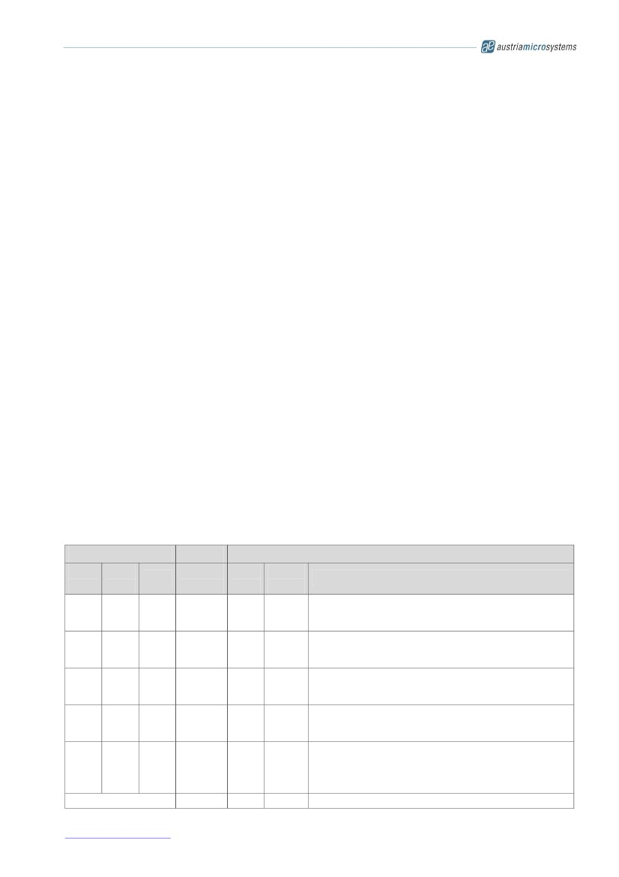

Data Sheet

7.4 Absolute Output Jitter and Hysteresis

Note that there is no hysteresis or additional filtering at the absolute output. This allows a determination of the

magnet’s absolute position within one pole pair down to submicron range.

Due to the intentionally omitted hysteresis and due to noise (e.g. from weak magnetic fields), the absolute output

may jitter when the magnet is stationary over the chip.

In order to get a stable 12-bit absolute reading, two common methods may be implemented to reduce the jitter.

7.4.1

Adding a Digital Hysteresis

The hysteresis feature of the incremental outputs is described in 7.2. An equivalent function can be implemented

in the software of the external microcontroller. The hysteresis should be larger than the peak-to-peak noise

(=jitter) of the absolute output in order to mask it and create a stable output reading.

Remark: the 2-bit hysteresis on the incremental output (=3.9µm) is equivalent to a hysteresis of 8LSB on the

absolute output.

7.4.2

Implementing Digital Filtering

Another useful alternative or additional method to reduce jitter is digital filtering. This can be accomplished

simply by averaging, for example a moving average calculation in the external microcontroller. Averaging 4

readings results in 6dB (=50%) noise and jitter reduction. An average of 16 readings reduces the jitter by a

factor of 4.

Averaging causes additional latency of the processed data. Therefore it may be useful to adjust the depth of

averaging depending on speed of travel. For example using a larger depth when the magnet is stationary and

reducing the depth when the magnet is in motion.

7.5 Z-axis Range Indication (“Red/Yellow/Green” Indicator)

The AS5311 provides several options of detecting the magnet distance by indicating the strength of the

magnetic field. Signal indicators MagINCn and MagDECn are available both as hardware pins (pins 1 and 2) and

as status bits in the serial data stream (see Figure 8). Additionally the LIN status bit indicates the non-

recommended “red” range. The MAGnitude register provides additional information about the strength of the

magnetic field (see Figure 9).

The digital status bits MagINC, MagDec, LIN and the hardware pins MagINCn, MagDECn have the following

function:

Table 5. Magnetic Field Strength Red-Yellow-Green Indicators

Status Bits

Mag

INC

0

MAG

LIN

M11..

M0

3F hex

Hardware Pins

Mag

INCn

Off

Mag

DEC

0

Mag

DECn

Off

Description

No distance change

Magnetic input field OK ( GREEN range, ~10…40mT peak

amplitude)

Distance increase; this state is a dynamic state and only

active while the magnet is moving away from the chip.

Magnitude register may change but regulates back to 3F hex.

Distance decrease; this state is a dynamic state and only

active while the magnet is moving towards the chip.

Magnitude register may change but regulates back to 3F hex.

YELLOW range: magnetic field is ~3.4….54.5mT.

The AS5311 may still be operated in this range, but with

slightly reduced accuracy.

RED range: magnetic field is <3.4mT (MAG <20) or >54.5mT

(MAG >5F).

It is still possible to operate the AS5311 in the red range, but

not recommended.

Not available

0

0

1

0

3F hex

Off

Off

1

0

0

3F hex

20 hex-

5F hex

Off

Off

1

1

0

On

Off

1

1

1

<20 hex

>5F hex

On

On

All other combinations

n/a

n/a

www.austriamicrosystems.com

Revision 1.05

14 - 23

AS5311

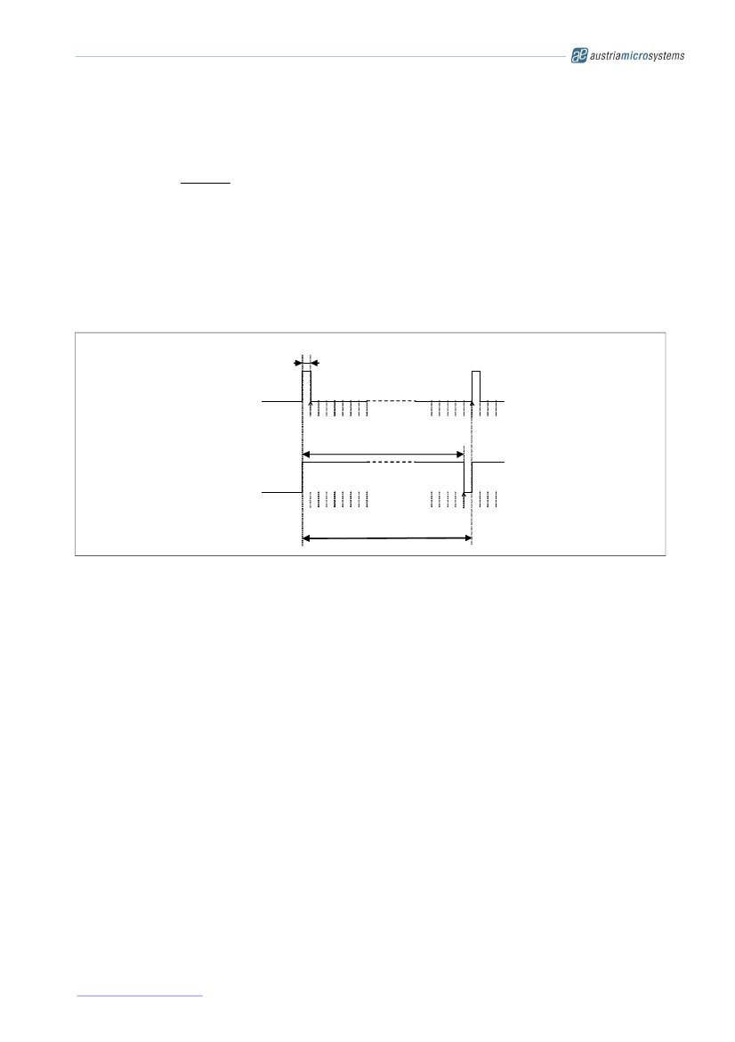

Data Sheet

8 Pulse Width Modulation (PWM) Output

The AS5311 provides a pulse width modulated output (PWM), whose duty cycle is proportional to the relative

linear position of the magnet within one pole pair (2.0mm). This cycle repeats after every subsequent pole pair:

Position =

t on ⋅ 4098

(t on + toff ) − 1

A linear position of 1999.5µm = digital position 4095

will generate a pulse width of t on = 4097µs and a pause toff = 1µs

for digital position = 0 – 4094

Exception:

The PWM frequency is internally trimmed to an accuracy of ±5% ( ±10% over full temperature range). This

tolerance can be cancelled by measuring the complete duty cycle as shown above.

Figure 10. PWM Output Signal

Position

0 m

(Pos 0)

PW MIN

1µs

4098µs

PW MA X

1999.5 m

(Pos 4095)

4097µs

1/fPWM

9 3.3V / 5V Operation

The AS5311 operates either at 3.3V ±10% or at 5V ±10%. This is made possible by an internal 3.3V Low-

Dropout (LDO) Voltage regulator. The internal supply voltage is always taken from the output of the LDO,

meaning that the internal blocks are always operating at 3.3V.

For 3.3V operation, the LDO must be bypassed by connecting VDD3V3 with VDD5V (see Figure 11).

For 5V operation, the 5V supply is connected to pin VDD5V, while VDD3V3 (LDO output) must be buffered by a

2.2...10µF capacitor, which is supposed to be placed close to the supply pin.

The VDD3V3 output is intended for internal use only It must not be loaded with an external load.

The output voltage of the digital interface I/O’s corresponds to the voltage at pin VDD5V, as the I/O buffers are

supplied from this pin.

A buffer capacitor of 100nF is recommended in both cases close to pin VDD5V. Note that pin VDD3V3 must

always be buffered by a capacitor. It must not be left floating, as this may cause an instable internal 3.3V supply

voltage which may lead to larger than normal jitter of the measured angle.

www.austriamicrosystems.com

Revision 1.05

15 - 23

AS5311

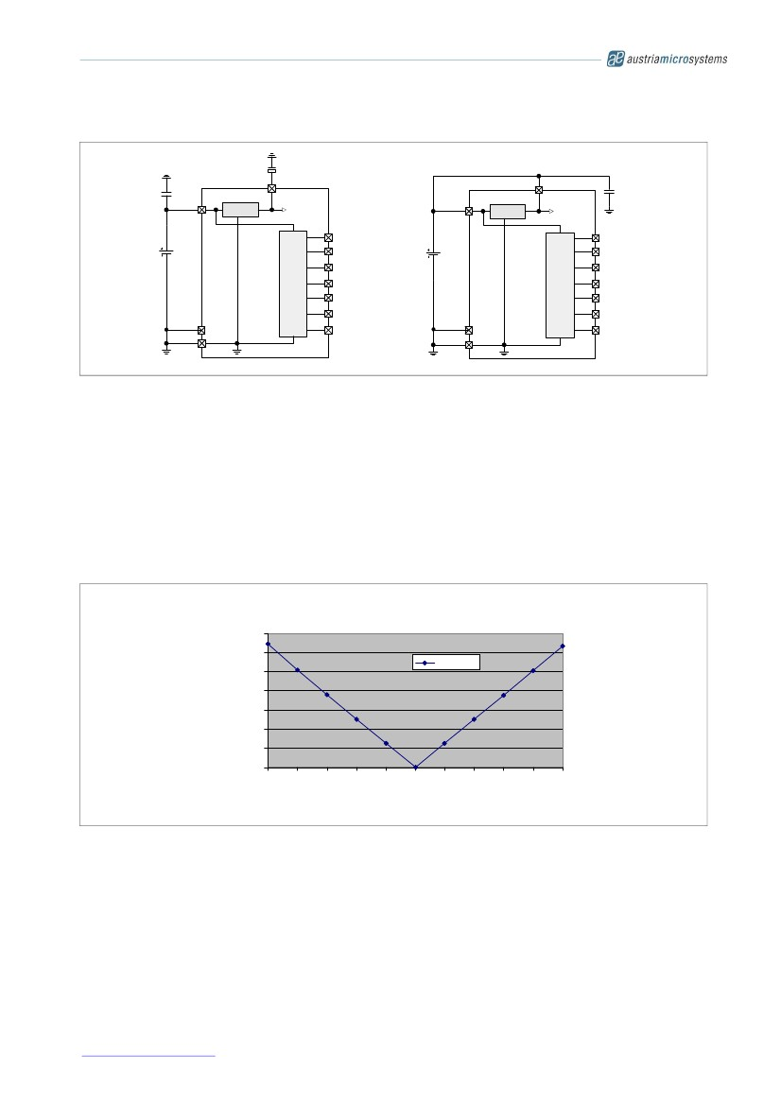

Data Sheet

Figure 11. Connections for 5V and 3.3V Supply Voltages

5V Operation

2.2...10 F

3.3V Operation

VDD3V3

VDD3V3

100n

100n

VDD5V

LDO

Internal

VDD

PWM

VDD5V

LDO

Internal

VDD

PWM

4.5 - 5.5V

Prog

VSS

I

N

T

E

R

F

A

C

E

DO

3.0 - 3.6V

CLK

CSn

A

B

Index

Prog

VSS

I

N

T

E

R

F

A

C

E

DO

CLK

CSn

A

B

Index

AS5311

AS5311

10 Magnet Specifications

10.1 Magnetization

The AS5311 accepts magnetic multi-pole strip or ring magnets with a pole length of 1.0mm. Recommended

magnet materials include plastic or rubber bonded ferrite or Neodymium magnets.

It is not recommended to use the AS5311 with other pole lengths as this will create additional nonlinearities.

Figure 12. Additional Error from Pole Length Mismatch

AS5311 Systematic Linearity Error Caused by Pole

Length Deviation

70.00

60.00

Error [µm]

Error 50.00

[µm] 40.00

30.00

20.00

10.00

0.00

750 800 850 900 950 1000 1050 1100 1150 1200 1250

Pole Length [µm]

Figure 12 shows the error caused by a mismatch of pole length. Note that this error is an additional error on top

of the chip-internal INL and DNL errors (see 6.5). For example, when using a multi-pole magnet with 1.2mm pole

length instead of 1.0mm, the AS5311 will provide 1024 incremental steps or 4096 absolute positions over

2.4mm, but with an additional linearity error of up to 50µm.

The curvature of ring magnets may cause linearity errors as well due to the fact that the Hall array on the chip is

a straight line while the poles on the multi-pole ring are curved. These errors decrease with increasing ring

diameter. It is therefore recommended to keep the ring diameter measured at the location of the Hall array at

20mm or higher.

www.austriamicrosystems.com

Revision 1.05

16 - 23

AS5311

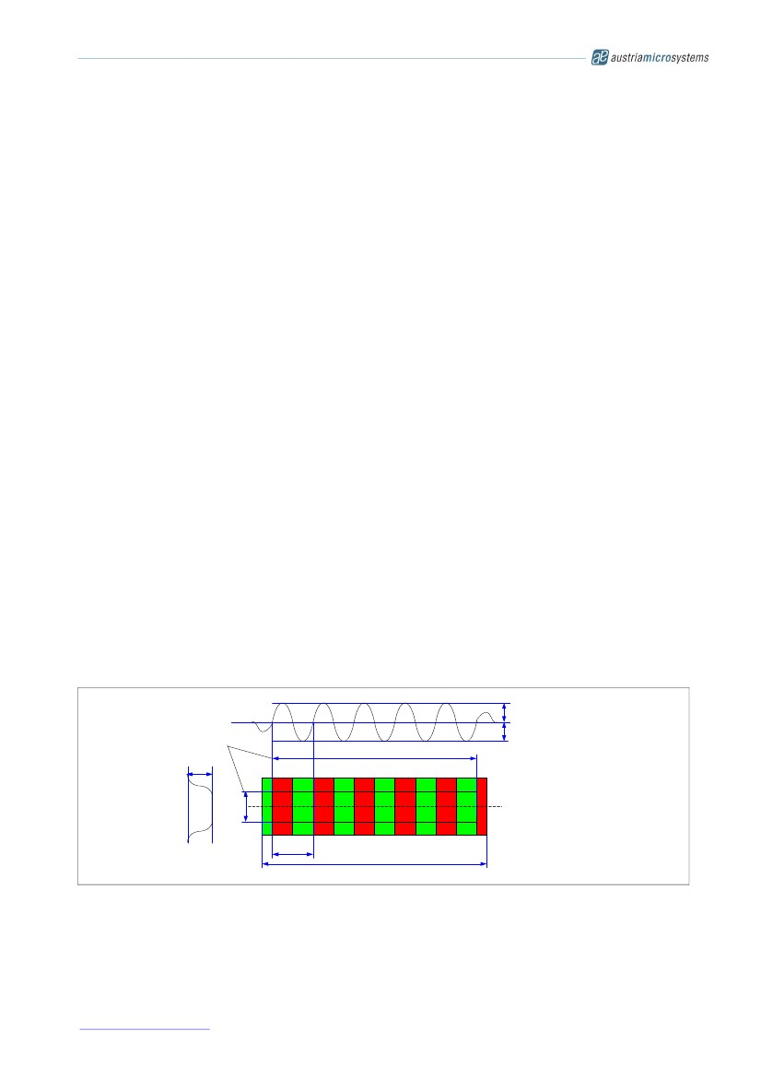

Data Sheet

10.2 Position of the Index Pulse

An index pulse is generated when the North and South poles are placed over the Hall array as shown in

Figure 14.

The incremental output count increases when the magnet is moving to the left, facing the chip with pin#1 at the

lower left corner (see Figure 14, top drawing). At the same time, the absolute position value increases.

Likewise, the position value decreases when the magnet is moved in the opposite direction.

10.3 Mounting the Magnet

10.3.1 Vertical Distance

As a rule of thumb, the gap between chip and magnet should be ½ of the pole length, that is Z=0.5mm for the

1.0mm pole length of the AS5311 magnets. However, the gap also depends on the strength of the magnet.

Typical gaps for AS5311 magnets range from 0.3 to 0.6mm (see 6.4).

The AS5311 automatically adjusts for fluctuating magnet strength by using an automatic gain control (AGC). The

vertical distance should be set such that the AS5311 is in the “green” range. See 7.5 for more details.

10.3.2 Alignment of Multi-pole Magnet and IC

When aligning the magnet strip or ring to the AS5311, the centerline of the magnet strip should be placed

exactly over the Hall array. A lateral displacement in Y-direction (across the width of the magnet) is acceptable

as long as it is within the active area of the magnet. See Figure 14 for the position of the Hall array relative to

Pin #1.

Note: the active area in width is the area in which the magnetic field strength across the width of the magnet is

constant with reference to the centerline of the magnet (see Figure 13 ).

10.3.3 Lateral stroke of Multi-pole Strip Magnets

The lateral movement range (stroke) is limited by the area at which all Hall sensors of the IC are covered by the

magnet in either direction. The Hall array on the AS5311 has a length of 2.0mm, hence the total stroke is

maximum lateral Stroke = Length of active area – length of Hall array

Note: active area in length is defined as the area containing poles with the specified 1.0mm pole length. Shorter

poles at either edge of the magnet must be excluded from the active area (see Figure 13).

Figure 13. Active Area of Strip Magnet

Bpk Bpk

Active Area

Active area (length)

B

Active area

(width)

N

S

N

S

N

S

N

S

N

S

recommended

scanning path

2mm

strip length

www.austriamicrosystems.com

Revision 1.05

17 - 23

AS5311

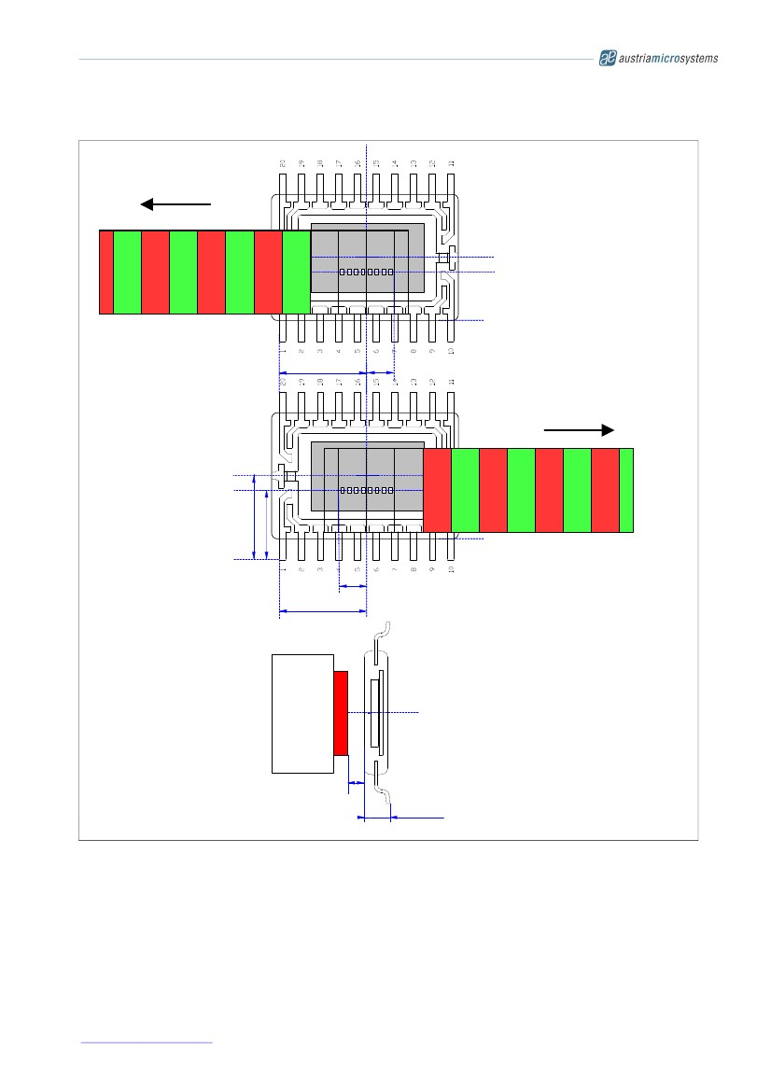

Data Sheet

Figure 14. Alignment of Magnet Strip with AS5311 Sensor IC

position value

increases

leftmost magnet position

Die C/L

S

N

S

N

S

N

S

N

S

N

3.0475±0.235

1.00

AS5311

Package

Outline

rightmost magnet position

Die C/L

position value

decreases

3.200±0.235

2.576±0.235

S

N

S

N

S

N

S

N

S

N

1.00

3.0475±0.235

vertical airgap

magnet

strip

carrier

see text

1.00 ± 0.1

Note: all dimensions are in mm

www.austriamicrosystems.com

Revision 1.05

18 - 23

AS5311

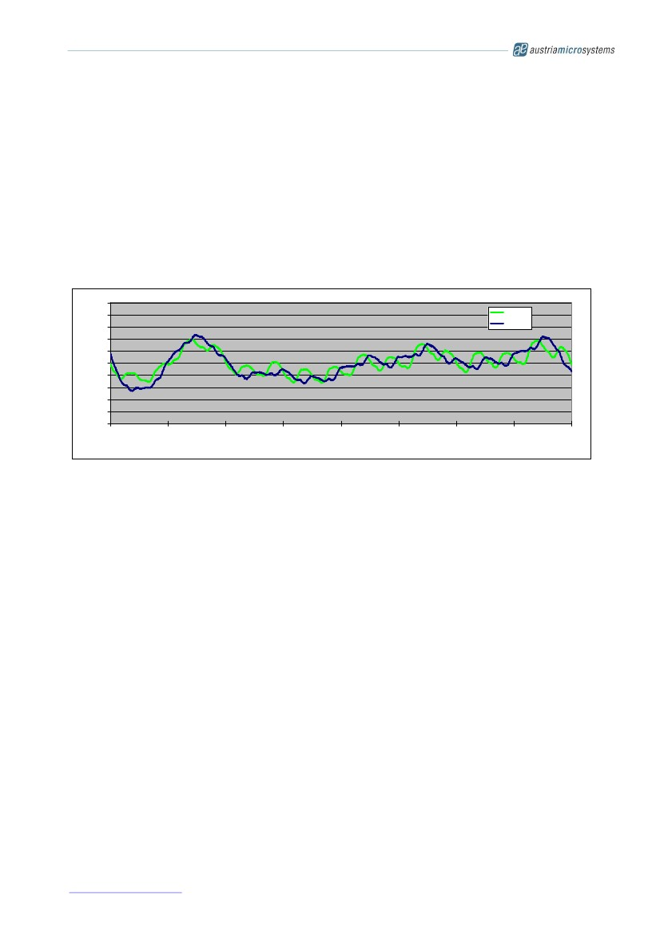

Data Sheet

11 Measurement Data Example

Figure 15 shows typical test results of the accuracy obtained by a commercially available multi-pole magnetic

strip.

The graph shows the accuracy over a stroke of 8mm at two different vertical gaps, 0.2mm and 0.4mm. As

displayed, the accuracy is virtually identical (about +/- 10µm) for both airgaps due to the automatic gain control

of the AS5311 which compensates for airgap changes.

The accuracy depends greatly on the length and strength of each pole and hence from the precision of the tool

used for magnetization as well as the homogeneity of the magnet material. As the error curve in the example

below does not show a repetitive pattern for each pole pair (each 2.0mm), this is most likely an indication that

the pole lengths of this particular sample do not exactly match. While the first pole pair (0...2mm) shows the

greatest nonlinearities, the second pole (2…4mm) is very precise, etc…

Figure 15. Sample Test Results of INL at Different Airgaps

25

20

15

10

5

0

-5

-10

-15

-20

-25

0

1000

2000

3000

INL MS10-10

z= 200µ

z= 400µ

Error [µm]

4000

X [µm]

5000

6000

7000

8000

Note: The magnet sample used in Figure 15 is a 10-pole plastic bonded ferrite magnet as shown in Figure 13.

The corresponding magnet datasheet (MS10-10) is available for download from the austriamicrosystems

website, magnet samples can be ordered from the austriamicrosystems online web shop.

www.austriamicrosystems.com

Revision 1.05

19 - 23

AS5311

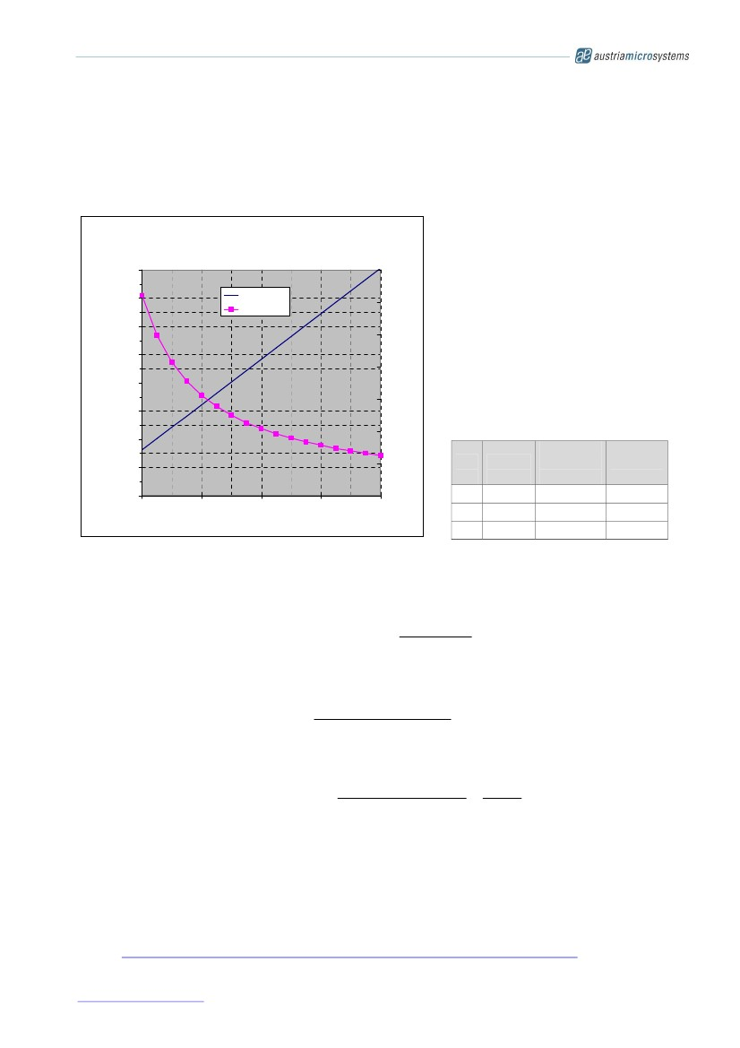

Data Sheet

12 AS5311 Off-axis Rotary Applications

The AS5311 can also be used as an off-axis rotary encoder, as shown in Figure 3. In such applications, the

multi-pole magnetic strip is replaced by a multi-pole magnetic ring. The ring can have radial or axial

magnetization.

Figure 16. Angular Resolution and Maximum Speed versus Ring Diameter

AS5311 off-axis rotary resolution & speed

160000

140000

120000

resolution [steps / rev]

700

resolution

speed rpm

600

500

400

max. speed [rpm]

In off-axis rotary applications, very high

angular resolutions are possible with the

AS5311.

The number of steps per revolution

increases linearly with ring diameter.

Due to the increasing number of pulses per

revolution, the maximum speed decreases

with increasing ring diameter.

Example:

a magnetic ring with 41.7mm diameter has

a resolution of 65536 steps per revolution

(16-bit) and a maximum speed of 305 rpm

100000

80000

300

60000

40000

20000

0

20

40

60

ring diameter [mm]

200

100

0

80

100

Res

[bit]

15

16

17

Steps /

Rev.

32768

65536

131072

Ring

Diameter

[mm]

20.9

41.7

83.4

Max

Speed

[rpm]

609

305

152

The number of incremental steps per revolution can be calculated as:

incremental _ steps = 1024 * nbr _ polepairs

incremental _ steps =

1024 * d * đ

2

Note that the circumference (d*π) must be a multiple of one polepair = 2mm, hence the diameter of the magnet

ring may need to be adjusted accordingly:

d=

nbr _ polepairs * 2mm

đ

The maximum rotational speed can be calculated as:

max_ rot _ speed =

where

nbr_polepairs

d

max_ lin _ speed * 60 39000

=

d *đd *đ

= the number of pole pairs at the magnet ring

= diameter of the ring in mm; the diameter is taken at the locus of the Hall elements

underneath the magnet

max_rot_speed = maximum rotational speed in revolutions per minute rpm :

max_lin_speed = maximum linear speed in mm/sec (=650 mm/s for AS5311)

further examples are shown in the “Magnet Selection Guide”, available for download from the

austriamicrosystems website

http://www.austriamicrosystems.com/eng/Products/Magnetic-Encoders/Linear-Encoders

Note:

www.austriamicrosystems.com

Revision 1.05

20 - 23

AS5311

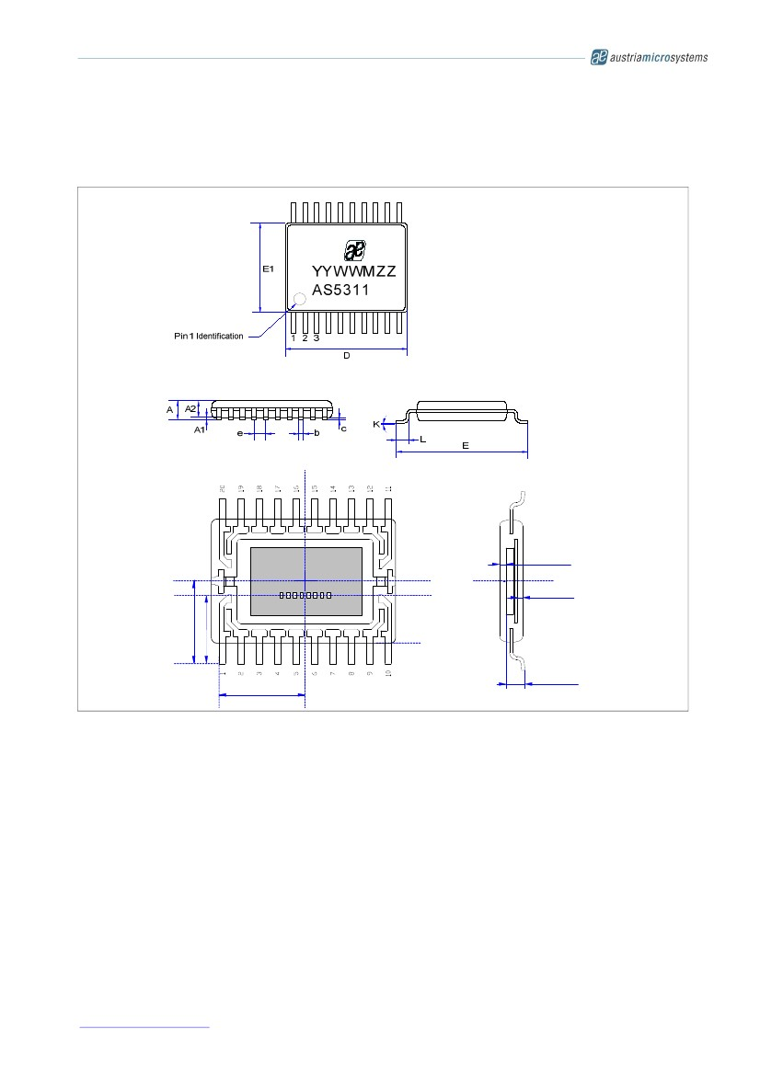

Data Sheet

13 Package Drawings and Marking

20 Lead Thin Shrink Small Outline Package – TSSOP20

Figure 17. AS5311 Package Dimensions and Hall Array Location

0.2299±0.100

Die C/L

0.2341±0.100

3.200±0.235

2.576±0.235

Package

Outline

0.7701±0.150

3.0475±0.235

www.austriamicrosystems.com

Revision 1.05

21 - 23

AS5311

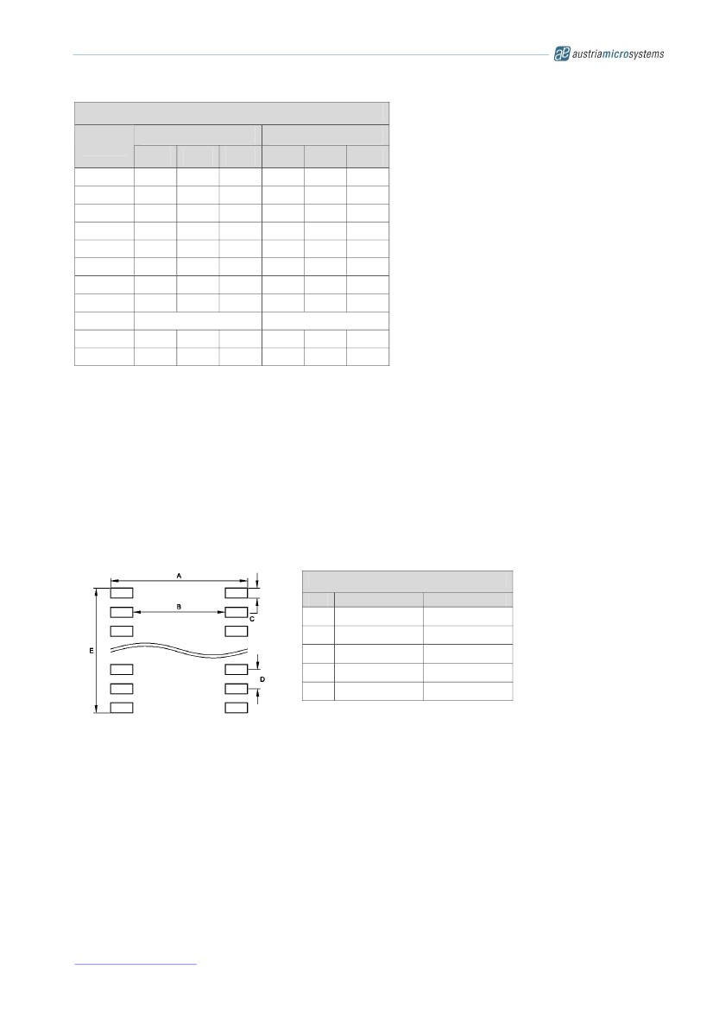

Data Sheet

Dimensions

mm

Symbol

Min

A

A1

A2

b

c

D

E

E1

e

K

L

0°

0.50

-

0.05

0.85

0.19

0.09

6.40

6.20

4.30

Marking: AYWWIZZ

inch

A: Pb-Free Identifier

Y: Last Digit of Manufacturing Year

WW: Manufacturing Week

I: Plant Identifier

ZZ: Traceability Code

Typ

-

-

0.90

-

-

6.50

6.40

4.40

0.65

-

0.60

Max

1.10

0.15

0.95

0.30

0.20

6.60

6.60

4.50

8°

0.75

Min

-

0.002

0.033

0.007

0.004

0.244

0.169

0°

0.019

Typ

-

-

0.035

-

-

0.252

0.173

.0256

-

0.024

Max

0.043

0.006

0.037

0.012

0.008

0.260

0.177

8°

0.030

JEDEC Package Outline Standard:

MO – 153

Thermal Resistance R th(j-a) :

89 K/W in still air, soldered on PCB.

IC's marked with a white dot or the letters

"ES" denote Engineering Samples

14 Ordering Information

Delivery:

Tape and Reel: 1 reel = 1000 devices

1 reel = 4500 devices

Tubes: 1 box = 100 tubes à 74 devices

for delivery in tubes

for delivery in tape and reel

Order # AS5311ASSU

Order # AS5311ASST

15 Recommended PCB Footprint

Recommended Footprint Data

A

B

C

D

E

mm

7.00

5.00

0.38

0.65

6.23

inch

0.276

0.197

0.015

0.026

0.245

www.austriamicrosystems.com

Revision 1.05

22 - 23

AS5311



Data Sheet

16 Revision History

Revision

1.01

1.02

1.03

1.04

1.05

Date

26-Jun-09

09-Apr-10

24-Sep-10

14-March-11

8-Sept-11

Owner

jja, jlu

agt

agt

mub

rei,mub

Description

Recommended footprint data updated

Delivery information updated

Fig.9 updated

Table 4. Parity bit change 1…17

IC Marking Fig. 17

Correction pin description, SSI communication

17 Copyrights

Copyright © 2011, austriamicrosystems AG, Schloss Premstaetten, 8141 Unterpremstaetten, Austria – Europe.

Trademarks Registered ®. All rights reserved. The material herein may not be reproduced, adapted, merged,

translated, stored, or used without the prior written consent of the copyright owner.

All products and companies mentioned are trademarks or registered trademarks of their respective companies.

18 Disclaimer

Devices sold by austriamicrosystems AG are covered by the warranty and patent indemnification provisions

appearing in its Term of Sale. austriamicrosystems AG makes no warranty, express, statutory, implied, or by

description regarding the information set forth herein or regarding the freedom of the described devices from

patent infringement. austriamicrosystems AG reserves the right to change specifications and prices at any time

and without notice. Therefore, prior to designing this product into a system, it is necessary to check with

austriamicrosystems AG for current information. This product is intended for use in normal commercial

applications. Applications requiring extended temperature range, unusual environmental requirements, or high

reliability applications, such as military, medical life-support or lifesustaining equipment are specifically not

recommended without additional processing by austriamicrosystems AG for each application.

The information furnished here by austriamicrosystems AG is believed to be correct and accurate. However,

austriamicrosystems AG shall not be liable to recipient or any third party for any damages, including but not

limited to personal injury, property damage, loss of profits, loss of use, interruption of business or indirect,

special, incidental or consequential damages, of any kind, in connection with or arising out of the furnishing,

performance or use of the technical data herein. No obligation or liability to recipient or any third party shall arise

or flow out of austriamicrosystems AG rendering of technical or other services.

Contact Information

Headquarters

austriamicrosystems AG

A-8141 Schloss Premstaetten, Austria

Tel: +43 (0) 3136 500 0

Fax: +43 (0) 3136 525 01

For Sales Offices, Distributors and Representatives, please visit:

http://www.austriamicrosystems.com/contact

www.austriamicrosystems.com

Revision 1.05

23 - 23